Invisible Queue: A Real-Time Animated Queue Simulation and Wait-Time Prediction System.

- Introduction

  - Purpose
This document outlines the functional and non-functional requirements for the software system titled “Invisible Queue: A Real-Time Animated Queue Simulation and Wait-Time Prediction System.”

The purpose of this system is to model service-counter queue dynamics, predict waiting times based on mathematical queue theories, and provide a decision-support tool that suggests whether it is worth waiting in the queue.

  - Scope
The Invisible Queue system is a web-based application that:
- Simulates customer arrivals and service processes.
- Displays an animated representation of a service counter.
- Maintains real-time queue length.
- Predicts expected waiting time using M/M/1 queue modeling.
- Computes a wait-worthiness decision score.
- Synchronizes simulation with system clock.
- Uses synthetic dataset for simulation control.
The system does not:
- Use real CCTV input.
- Perform face recognition.
- Integrate real payment systems.
- Connect to live physical sensors (future extension).

  - Definitions, Acronyms, Abbreviations
- Queue Length (Q) – Number of customers currently waiting.
- Arrival Rate (λ) – Average number of customers arriving per unit time.
- Service Rate (μ) – Average number of customers served per unit time.
- Utilization Factor (ρ) – Ratio λ / μ.
- Wq – Expected waiting time in queue.
- W – Expected total time in system.
- Wait-Worthiness Score (S) – Decision metric indicating whether waiting is advisable.
- Simulation Tick – One-second update cycle.

- Overall Description

  - Product Perspective
The system consists of five major modules:
1. User Interface Layer (Streamlit-based web UI).
2. Animation Engine.
3. Simulation Engine.
4. Prediction Engine.
5. Decision Logic Module.

Architecture:

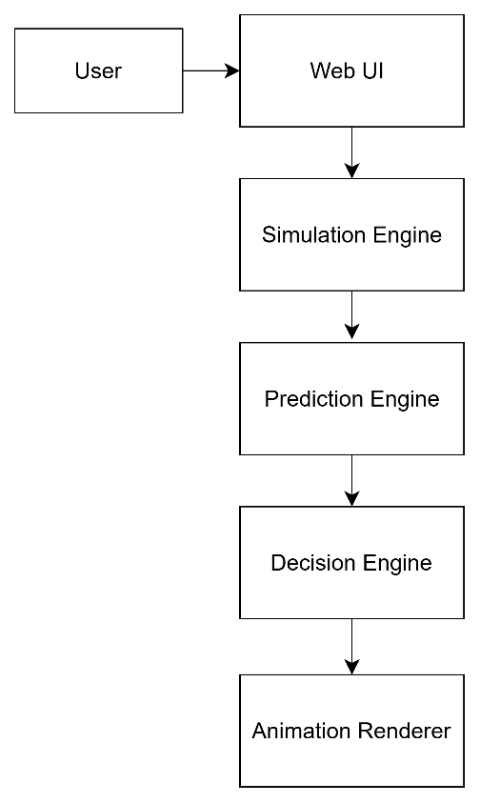

  - Product Functions (High -Level)
The system shall:
1. Simulate queue arrivals using probabilistic modelling.
2. Simulate service completion process.
3. Maintain queue state dynamically.
4. Display animated service counter.
5. Compute expected waiting time.
6. Compute wait-worthiness score.
7. Synchronize updates with real-time clock.
8. Limit maximum queue size to realistic constraints (<100).
9. Allow configurable parameters (λ and μ).

  - User Characteristics

Primary User:
- Service counter manager
- Administrative user
- Academic evaluator
Users are assumed to have basic familiarity with web applications.

  - Constraints
- Developed using Python 3.13.
- Web interface built using Streamlit.
- Runs on Windows operating system.
- Uses synthetic data for simulation.
- System assumes stable internet connection for initial deployment.
2.5 Assumptions and Dependencies
- Customer arrivals follow Poisson distribution.
- Service time follows exponential distribution.
- System clock is accurate.
- Synthetic data approximates real-world behaviour.

- Functional Requirements

FR-1: Queue Simulation
The system shall simulate customer arrivals based on arrival rate (λ).
Arrival probability follows Poisson distribution:
$$P(k)=\frac{e^{-λt}(λt)^{k}}{k!}$$
Where:
- $λ$= arrival rate (customers per unit time)
- $t$= time interval
- $k$= number of arrivals
Inter-arrival times follow exponential distribution:
$$f(t)=λe^{-λt}$$FR-2: Service Process
Service completion shall follow exponential distribution with rate (μ).
Probability density function:
$$f(t)=μe^{-μt}$$
Expected service time:
$$E[S]=\frac{1}{μ}$$
Where:
- $μ$= service rate (customers served per unit time)

FR-3: Utilization Calculation
The system shall compute utilization factor:
$$ρ=\frac{λ}{μ}$$
Condition for stability:
$$λ<μ$$
If $λ≥μ$, the queue grows infinitely and the system becomes unstable.

FR-4: Waiting Time Estimation (M/M/1 Model)
The system shall estimate queue performance using the M/M/1 queuing model under the stability condition:
$$λ<μ$$
Where:
- $λ$= arrival rate
- $μ$= service rate
- $ρ=\frac{λ}{μ}$= utilisation factor

Expected number of customers in system:
$$L=\frac{λ}{μ-λ}$$
Expected number of customers in queue:
$$L_{q}=\frac{λ^{2}}{μ(μ-λ)}$$
Expected waiting time in queue:
$$W_{q}=\frac{λ}{μ(μ-λ)}$$
Equivalent form using utilization:
$$W_{q}=\frac{ρ}{μ-λ}$$
Expected total time in system:
$$W=\frac{1}{μ-λ}$$
Relationship (Little’s Law):
$$L=λW \\ L_{q}=λW_{q}$$
Numerical Stability Constraint (Implementation Safeguard):
To prevent computational singularity when $μ≈λ$, the implemented system computes:
$$W=\frac{1}{max⁡(μ-λ,ϵ)}$$
Where:
- $ϵ$is a small positive constant (e.g., 0.01)
- This ensures bounded output under near-saturation conditions.

FR-5: Wait-Worthiness Score
The system shall compute decision score $S$:
$$S=α(T_{threshold}-W)$$
Where:
- $T_{threshold}$= maximum acceptable waiting time
- $W$= expected total waiting time
- $α$= scaling factor

Decision Rule:

If $S>0$→ Worth Waiting
If $S≤0$→ Not Worth Waiting

Optional normalized version (for UI scaling):
$$S_{norm}=\frac{T_{threshold}-W}{T_{threshold}}$$
FR-6: Real-Time Synchronization
The system shall update simulation at 1-second intervals synchronized with system clock.

FR-7: Animation Rendering
The system shall visually render:
- Service counter
- Clerk
- Customers in non-linear queue arrangement
- Real-time clock display

- External Interface Requirements

User Interface Requirements:
- Web-based interactive UI using Streamlit
- Real-time queue animation
- Display of computed metrics and decision score

Hardware Interface:
None

Software Interface:
- Python 3.x
- Streamlit
- NumPy
- Pandas

Communication Interface:
None currently

- Non-Functional Requirements

NFR-1 Performance
System shall update within 1-second latency.

NFR-2 Usability
User interface shall be intuitive and visually understandable.

NFR-3 Reliability
System shall operate continuously for at least 1 hour without failure.

NFR-4 Maintainability
System shall follow modular architecture with separation of concerns.

NFR-5 Scalability
System shall allow integration of ML-based predictive modeling in future versions.

- Software Process Model

The development follows the Agile Scrum model.

Characteristics:
- Sprint-based incremental development
- Continuous integration
- Modular build-up
- Iterative refinement
- Backlog prioritization

Planned Sprints:
- Sprint 1: Basic simulation engine
- Sprint 2: Waiting time prediction
- Sprint 3: Decision scoring
- Sprint 4: Animation integration
- Sprint 5: Optimization and testing

- Use Case Diagram:

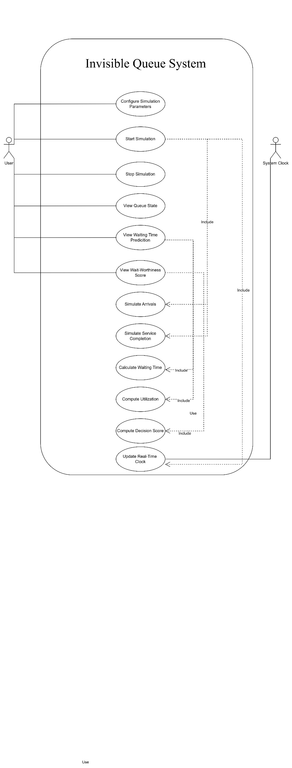

8. Requirements Traceability Matrix
Requirement ID | Requirement Description | Module | Class | Method(s)
FR-1 | Simulate customer arrivals using Poisson model | Simulation Module | QueueSimulator | simulate_arrival()
FR-2 | Simulate customer arrivals using Poisson model | Simulation Module | QueueSimulator | simulate_service()
FR-3 | Compute utilization factor (ρ = λ / μ) | Prediction Module | PredictionEngine | calculate_utilization()
FR-4 | Compute waiting time W and Wq using M/M/1 model | Prediction Module | PredictionEngine | calculate_waiting_time(), calculate_waiting_time_queue()
FR-5 | Compute decision score S and evaluate worthiness | Decision Module | DecisionEngine | compute_score(), evaluate_decision()
FR-6 | Synchronize system with real-time clock (1-second updates) | UI Module | Web UI | timer_loop()
FR-7 | Render animated queue and display metrics | Animation Module | AnimationRenderer | render_queue(), render_metrics(), render_clock()
NFR-1 | Update system within 1-second latency | UI / Simulation | Web UI / QueueSimulator | timer_loop(), step()
NFR-2 | Provide intuitive and readable interface | UI Module | Web UI | render_interface()
NFR-3 | Maintain modular architecture | All Modules | All Classes | Class Separation
NFR-4 | Ensure system stability when λ < μ | Prediction Module | PredictionEngine | stability_check() (implicit)
NFR-5 | Support scalability for ML integration | Architecture Level | Modular Design | N/A

